**Library Management System**

**(Web App)**

**Submitted by**

Muhammad Mursaleen, LDBTTE-19-23

**BSIT**

Session (2019-23)

**Supervised by**

Mr. Kamran Qadir Sb.

DEPARTMENT OF INFROMATION TECHNOLOGY



**BAHAUDDIN ZAKARIYA UNIVERSITY MULTAN, SUB**

**CAMPUS LODHRAN, PAKISTAN**

# **Final Approval**

It is certified that we have read the report entitled “Library Management System” submitted by **Muhammad Mursaleen** and it is our judgment that this report is of sufficient standard to warrant its acceptance by Department of Information Technology, Bahauddin Zakariya University Multan, Sub Campus Lodhran for the partial fulfillment of the requirement for the Bachelor of Science in Information Technology.

Approved on __________________

By

Name: Muhammad Mursaleen

Roll No: LDBTTE-19-12

Supervisor External Examiner

Signature: Signature:

_____________________ _____________________

Name: Name:

_____________________ _____________________

Designation: Designation:

_____________________ _____________________

Head of Department

Signature:

_____________________

Mr. Kamran Qadir

Department of Information Technology, Bahauddin Zakariya University, Multan, Sub Campus Lodhran

Dedication

To our parents, teachers and all of the people who prayed for us. A special feeling of gratitude to my loving parents; I also dedicate this dissertation to my friends and family who have supported me throughout the process.

Acknowledgments:

With the blessings of Almighty Allah and prayers of our parents I have made this attempt to achieve the goal that was set for me to complete the Bachelor degree. Although the project was complex and complicated, I put my maximum effort to fulfill the goal.

I deeply indebted to our teachers and special gratitude to our final year project supervisor.

I deeply indebted to our teachers and special gratitude to our final year project supervisor,

**Mr. Kamran Qadir** whose guidance, suggestion and encouragement remained a continuous source of inspiration for us throughout the entire course of project.

I wish to seize this opportunity to thanks all our friends, who very patiently guided us through all the stages of the project with regard to system support. Finally, a special thanks to our parents, friends, and our family for their prayers, unending support and encouragement during the course of a long and tedious struggle to accomplish the work in time.

**Name: Muhammad Mursaleen**

**Roll No.: LDBTTE-19-12**

**Department: BSIT**

**Session: 2019-23**

Project Brief

PROJECT NAME:

Library Management Web App

UNDERTAKEN BY:

Muhammad Mursaleen

SUPERVISED BY:

Mr. Kamran Qadir

STARTING DATE:

01-01-2022

COMPLETION DATE:

01-06-2-2023

COMPUTER USED:

8GB RAM, 128GB SSD

OPERATING SYSTEM:

Windows Operating System

SOURCE LANGUAGE(S):

Html, CSS, JavaScript, Bootstrap

DBMS USED:

XAMP, MYSQL

TOOLS/PACKAGE:

VS Code, XAMP server

Table of contents

ABSTRACT

**Chapter 1**

**Introduction**

Contents

* 1. Project Statement
  2. Need of Project
  3. Scope of Project
  4. Objectives of the Project

**Chapter 2**

**System Requirement Analysis**

2.1 System Requirement Analysis

2.2 Analysis of existing system

2.3 Data Gathering

2.4 Data Analysis

2.5 New System Requirements

2.6 Description of present system

2.6.1 Limitations of present system

2.6.2 Proposed system

2.6.3 Existing System

2.6.4 Drawback of existing system

2.6.5 Advantage of Proposed system

2.6.6 Comparison

2.7 Feasibility Study

2.7.1 Technical Feasibility

2.7.2 Economic Feasibility

2.7.3 Operational Feasibility

2.8 Functional Requirement

2.9 Non-Functional Requirement

2.10 Domain Requirement

**Chapter 3**

**System Design**

3.1 Introduction to system design

3.2 Design objectives of the system

3.3 UML Diagrams

3.3.1 Use case Diagram

3.3.2 Class Diagram

3.3.3 Sequence Diagram

3.3.4 State Diagram

3.3.5 Activity Diagram

3.3.6 Component Diagram

3.4 Logical database design and relational model

3.5 UX/UI Design of Web App

**Chapter 4**

**System Implementation & Development**

4.1 Implementation

4.2 Front End Design

4.3 Back End Design Using XAMP Server

4.4 Database Tier

4.5 Security and Encryption

4.6 Tools Used

**Chapter 5**

**Testing**

5.1 Introduction to testing

**Chapter 6**

**User Guide**

6.1 Conclusion & Future Scope

**Chapter 7**

**References**

# Chapter 1

# Introduction

Abstract

Library management system is a project which aims in developing a computerized system to maintain all the daily work of library. This project has many features which are generally not available in normal library management systems like facility of user login and a facility of teacher’s login. It also has a facility of admin login through which the admin can monitor the whole system. It also has facility of an online notice board where teachers can student can put up information about workshops or seminars being held in our colleges or nearby colleges and librarian after proper verification from the concerned institution organizing the seminar can add it to the notice board. It has also a facility where student after logging in their accounts can see list of books issued and its issue date and return date and also the students can request the librarian to add new books by filling the book request form. The librarian after logging into his account i.e., admin account can generate various reports such as student report, issue report, teacher report and book report Overall this project of ours is being developed to help the students as well as staff of library to maintain the library in the best way possible and also reduce the human efforts. The basic theme is that the work which is currently being done manually in the University’s library be now done with the help of computer. This will bring efficiency in the system and also better facilitate the users i.e., students of the institution.

* 1. Project Statement

Library Management System is an application which refers to library systems which are generally small or medium in size. It is used by librarian to manage the library using a computerized system where he/she can record various transactions like issue of books, return of books, addition of new books, addition of new students etc. Books and student maintenance modules are also included in this system which would keep track of the students using the library and also a detailed description about the books a library contains. With this computerized system there will be no loss of book record or member record which generally happens when a non-computerized system is used. In addition, report module is also included in Library Management System. If user’s position is admin, the user is able to generate different kinds of reports like lists of students registered, list of books, issue and return reports. All these modules are able to help librarian to manage the library with more convenience and in a more efficient way as compared to library systems which are not computerized. This project is for the automation of library system of an institution. Books play an important role in today’s education system and therefore I have selected to work on this project for the sake of automating the library.

* 1. Need of Project

With the increase in the number of readers, better management of libraries system is required. The Integrated Library Management system provides us the ease of issuing, renewing, or reserving a book from a library within our town through our phone. The Integrated Library Management system is developed on the Web platform which basically focuses on issuing, renewing and reserving a book.

* 1. Scope of Project

In an institution, there may be many systems at work. The scope of our project is limited to the library system of the institution. That is, the system of maintaining books information, borrowing and returning of the books, new entry and log for the books and related reports. The system also stores limited information about the students and the faculty. The Scope of this project is limited to the basic Operations and functionalities of a library which includes Searching for a book, issuing a Book and Returning a book within a time frame. It is not confined for only one library. It can be used for several libraries. Users can search for their desired book in a single instant. Users can view their profile to check any outstanding dues against their IDs. Librarian can also view a certain user’s profile by searching their name.

* 1. Objectives of the Project

The objective of the project is to automate the current manual system of the library. This includes activities:

* To facilitate add/delete/update books’ data
* To facilitate borrowing and returning of books electronically
* To facilitate librarian and Institution’s management with handful of books information/status on a particular subject, whenever needed
* Reports regarding books’ availability and borrowing

The motivation behind the development of Library Management System is to reduce the time wastage while keeping records manually in a physical or tangible material. It provides different facilities to the users and make the system secure and error free. It reduces labor and provide the same functionalities as of the manual system but with less time wastage and quick response. This project has been developed to carry out the processes easily and quickly, which is not possible with the manuals systems. Features of this Project will save the user time by providing a user-friendly interface to search for their desired books.

# Chapter 2

# System Requirement Analysis

2.1 System Requirement Analysis

The most important thing in designing and developing a system is to understand the existing system, its problem and limitation. A good understanding of the system enables developer to identify the correct problem or limitation and suggested realistic solutions to the problems. We must thoroughly understand the problem of the existing system and determine how the computer can be used to makes its operation more efficient. The main responsibility of conducting system analysis, to learn relevant facts about working of the existing system, to make our new system advance and accurate. It is the responsibility of designer and developer to analyze it and assemble recommendations for the system. Therefor the study of the working of the system and limitations of the existing system is an important task design and development phase.

2.2 Analysis of Existing System

The analysis is preliminary concerned with studying of current system which is in use.

2.3 Data Gathering

In data gathering technique we collect the data which is related to our project and on the behalf of this data we decide which method is suitable to make our project work efficiently.

The technique or method which is used to gather information required persons with sensitivity common sense and knowledge what or when to gather and what channel to use in securing the information.

Two common data gathering methods are:

* Interviews
* Questioners
* In interview two are more people are meet to share their opinion and different purposes. Questioners is also a very popular and effective method to gather data about our problems.

2.4 Data Analysis

After collecting the data from peoples or users by doing questioning or by interviews we do data analysis (DA). DA is a practice of science for examining the raw data to get organize so that useful information can be extracted from it.

The process of organizing and thinking about data is a key to understanding what the data contain and what no contain. Data Analysis is the process of systematically applying statistical and/or logical techniques to describe and illustrate, condense and recap and evaluate data.

The collected data serves as foundation for the documentations of the system analysis phase.

2.5 New System Requirements:

The purpose of gathering and analyzing the data is to established the system requirements because the development and design of the new system will be based on these collected requirements.

Requirement Analysis provides the software developer and designer with a model of:

* System GUI
* System Function
* System Behavior

2.6 Descriptions of the Present System

A library management system is software that is designed to manage all the functions of a library. It helps librarian to maintain the database of new books and the books that are borrowed by members along with their due dates. This system completely automates all our library's activities.

2.6.1 Limitation of Present System

Manual systems are also slow to operate. Instead of using a computer to issue and take back books, locating and updating a card index is slow and laborious. Manual systems are unable to store large amounts of data efficiently. Digitization violates the copyright law as the thought content of one author can be freely transferred by others without his acknowledgement.

2.6.2 Proposed System

Proposed system is an automated Library Management System. Through our software user can add members, add books, search members, search books, update information, edit information, borrow and return books in quick time. Our proposed system has the following advantage:

* User Friendly Interface
* Fast access to the database
* Less error
* High Storage Capacity
* Quick Transaction

2.6.3 Existing System of Online Library Management System

The system designer must understand the existing system before he does anything to improve this existing system. The phase of understanding includes the study of getting knowledge about each and every work done in already existing system. I gather data from different perspective first of all then I have understood the whole process of the system

* How it works?
* What types of entities are acting in the system?
* What are their functions to perform?
* The limits?

I have prepared a questioner including different types of question in it which help me to know actual requirements of the proposed system.

2.6.4 Drawbacks of the Existing System

Drawbacks, problems, or weakness that or in the other word undesirable conditions, and situation which prevent the system to overcome the complete goal of the system.

Some of the major drawbacks are as follows:

* Slow, tedious, time consuming
* Lack of security
* Information redundancy
* Reliability
* Visual Appearance

2.6.5 Advantage of the Proposed System

Saves time and reduces overheads. Reduce library's operating cost. Customized reports for better management. Remove manual processes to issue books and maintain records. Library management system benefits provide online and offline storage, automated backups, and easy upgrades to simplify and enhance the learning process with its efficient cloud data management.

2.6.6 Comparison

In addition to storing content, digital libraries provide a way to organize, search, and retrieve the contents of a collection. Whereas traditional libraries emphasize the archive and preservation of physical items especially books and periodicals that were the custodians of the librarian library.

2.7 Feasibility Study

A feasibility study is the test report of a proposed system. It identifies the proposed system workability, impact on the organization, ability to meet user needs, and effective use of system resources. System feasibility is accessed in three principal ways:

* Technical
* Economical
* Operational

2.7.1 Technical Feasibility

We need the project be feasible in the way the technical resource should be present.

For example, there should be proper hardware, software and the persons who can operate the system. A system request is technically feasible if the organization obtain the equipment and personal to develop and operate the system.

Technical Feasibility is frequently the most difficult area objectives and performance of the system also depends upon it. It is essential that the process of analysis must be conducted in parallel with the assessment of technical feasibility.

2.7.2 Economic Feasibility

The economic feasibility assessment is to determine cost benefit analysis. It helps project planners determine the positive economic benefits to the organization that the proposed system will provide and help quantify them. It is generally the bottom-line consideration for most systems.

2.7.3 Operational Feasibility

A system must have a user-friendly environment. An operational feasible system is one that will be used effectively after it has been developed. If user has difficulty with in new system, then it will no produce the expected benefits. User friendly interface makes it easier for the users. The proposed system will be user friendly, menu driven and end user will operate the system. After gathering all information and telling the management what would be require to operate this database, the management has decided to work more on the project and develop a good project. We need a skill person to operate the system.

2.8 Functional Requirement

Functional Requirement are product feature or functions that developers must implement to enable user to accomplished their task. So, it’s important to make them clear both for the development team and stakeholders. Generally, functional requirements describe system behavior under specific conditions. These are below some of the functional requirements of the Library Management System Web App.

Allow the librarian to add and remove new members. Allow the user to search for books based on title, publication date, author, etc., and find their location in the library. Users can request, reserve, or renew a book. Librarian can add and manage the books. The system should notify the user and librarian about the overdue books. The system calculates the fine for overdue books on their return.

2.9 Non-Functional Requirement

Non-functional requirement, not related to system functionality, rather define how the system should perform. Most non-functional requirements relate to the system as a whole. They include constraints on timing, performance, reliability, security, maintainability, accuracy, the development process, standards, etc.

Some examples are:

The website page should be load in 3 seconds with the total number of simultaneous users <5 thousands. The system should be able to handle 1 million plus users without performance deterioration. They should work on the fast internet.

2.10 Domain Requirements

Domain Requirements are the requirements which are characteristic of a particular category or domain of the project. The basic function that a system of a specific domain must necessary exhibit come under this category. Describes main classes and relationships which could be used during analysis phase to better understand domain area for Integrated Library System (ILS).

Chapter 3

System Design

3.1 Introduction to System Design

“A system is a collection of elements or components that are organized for a common purpose to carry out specific activity to perform a duty or solve a problem.”

Systems design is the process or art of defining the architecture, components, module, interfaces and data for a system to satisfy specified requirements.

3.2 Design Objectives of Proposed System

Before designing any computer-based system, it is essential and helpful to establish the objectives that the computer base system should satisfy. So that we have argue to build a new system and if objectives of proposed system are clear it will give help us in designing this system. I make the following objectives of Library Management System Web app.

* Efficiency
* Simplicity
* Best Appearance

The proposed system should be efficient and faster than the existing system.

Data Security

It refers to protection from any accidental loss or loss of data. The data required for decision making is very important and valuable. Therefore, the reliability of the system may be secure by giving the users, librarian, admin password and individual e-mail so in this way they can see their own data and update or delete just their own record and not able to disturb others record/data.

Accuracy

The system will provide accurate information, because in this system standardized algorithms, efficient techniques and advance tools has been used to handle this project database and the whole project.

Flexibility

The system allows for changes, its layout, new fields and features can easily be added into it. It can be change according to its new requirements in the future.

Use Friendly

The system of online digital library system must be user friendly so that the users can access the system by GUI (Graphical User Interface). It is the common way to maximize the users of our library management system.

Reliability

The new library management web system reliable than existing manual library system due to its accuracy and security so that timely decision may be possible.

Performance

The proposed system should reduce the time and efforts required to retrieve information. It should have the capability to answer various quarries instantly and efficient.

3.3 The Applied Approach

There are different types of applied approaches in software development. One such approach/process we used in our system is “Increment Model”. The development process base on the **Increment model** is split into several iterations (“Lego-Style” modular software design is required!). New software modules are added in iteration with no or little change in earlier added modules. The development process can go either sequentially or in parallel. Parallel development adds to the speed of delivery, while many repeated cycles of sequential development can the project long and costly.

The phases in Incremental Model are:

* Planning
* Requirement Analysis
* System & Software Design
* Details design
* Development
* Testing
* Delivery
* Maintenance

Incremental Model

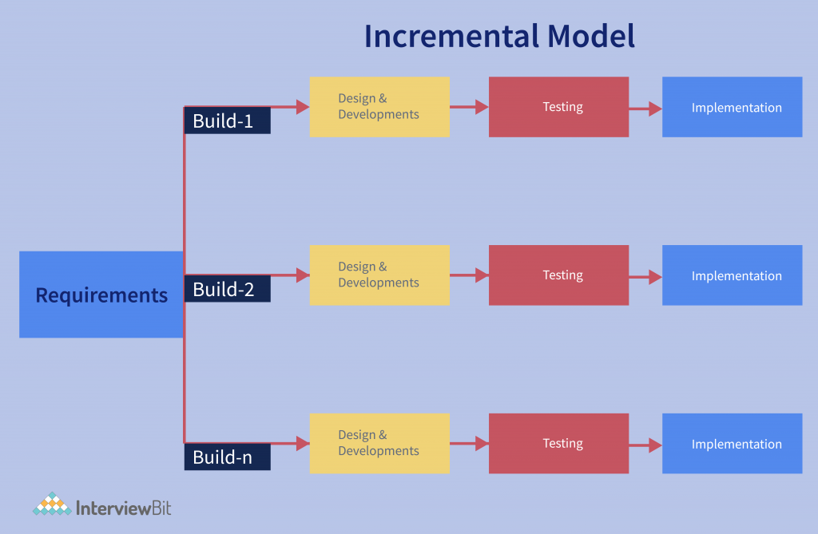

Fig: 3.3 Increment Model

Source:https://www.google.com/search?rlz=1C1UEAD_enPK1057PK1057&sxsrf=APwXEdeUmuKQXiYfsuLw_B5Lmp0Np-sEWQ:1686590330214&q=incremental+model+in+library+management+system&tbm=isch&sa=X&ved=2ahUKEwil8o3Mnr7_AhWX_7sIHdcUCQ4Q0pQJegQICxAB&biw=1011&bih=600&dpr=1#imgrc=FAYmUYa8dYzAZM

3.3.1 Requirement Analysis & Definitions

All possible requirements of the system to be developed are capture in in this phase. Requirements are set of functionalities and constraints that the end users (who will be the users of the system) expects from the system.

The requirements are gathered from the end users by consultations, these requirements are analyzed for their validity and the possibility of incorporating the requirements in the system to be development is also studied. Finally, a Software Specification Document is created which serves the purpose of the guideline for the next phase of the model.

3.3.2

Before start actual coding, it is highly important understand what we are going to create and what it should look like? The requirements specifications for first phase are studied in this phase and system design is prepared.

System design helps in specifying hardware and system requirements and also helps in defining overall system architecture. The system design specifications serve as input for the next phase of the model.

We can see these system designs components:

* UML Diagrams
* Database Design
* UX/UI Design

3.4 UML Diagrams

UML is a standard language for specifying, visualizing, constructing, and documents of software system.

* UML stands for Unified Modeling Language
* UML is different from the other programming languages like C++, Java
* UML is a pictorial language is used to make software blue prints

So, UML can be described as a general-purpose visual modeling language to visualize, specify, construct and document software system. Although the UML is generally used to model software system but it is not limited within this boundary. It is also used to model non software systems as well like process flow in a manufacturing unit etc.

UML is not a programming language but tools can be used to generates code in various languages in UML diagrams. UML has a direct relation with object-oriented analysis and design. After some standardization UML is become an OMG (Object Management Group) standard.

Following diagram are covered:

* Use case Diagram
* Class Diagram
* Sequence Diagram
* State Machine Diagram
* Activity Diagram
* Component Diagram

3.4.1 Use Case Diagram

To model a system that most important aspect is to capture the dynamic behavior. To clarity a bit in detail, dynamic behavior means behavior of the system when it is running or operating.

So only static behavior is not sufficient to a model system rather dynamic behavior is more important than static behavior. In UML there are five diagrams available to model dynamic nature and use cases diagram is one of them.

Now as we have to discuss that the use case diagram is dynamic in nature there should be some internal or external factors for making the interactions.

These internal and external agents are known as actors. So, use cases diagram are consist of actor, use cases and their relationship. The diagram is used to model the system/subsystem of an applications. A single use case diagram captures a particular functionality of a system.

So, to model the entire system numbers of use case diagrams are used.

Graphical Notation:

The basic components of Use Case diagrams are the actor, the Association and the Use Case.

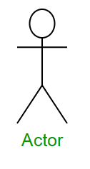Actor

An actor, as mentioned, is the user of the system and is shows in the figure. The role of the user is written beneath the icon. Actors are not limited to humans. If a system communicates with another application, and expects or delivers output, then that application can also be considered an actor.

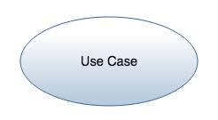Use Case

A use case is a functionality provided by the system, typically described as verb + object (e.g., Register Car, Delete Car). Use case are shown with the help of an ellipse. The name of the use case should be written in the ellipse.

Association

Association

Association is used to link Actors with Use Cases, and indicate that an actor participates in Use Case in some form. Association is represented by a line connecting the Actor and the Use Cases.

Relationships

Relationships among the use case and actor, relationships between an actor and a use case are represented with a simple line. For relationships among use cases, use arrow labeled either “use cases” or “extends” . A “use cases” relationships indicates that one use cases is needed by another in order to perform a task. An “Extend” relations indicates alternative options under a certain use case.

System Boundry Boxes (Optional)

A rectangle can be drawn around the use case, called the system boundry box, to indicate the scope of the system. Anything with the box functionality that is in scope and anything outside the box is not. System boundtry box are rarely used. Package (Optional) are UML Contracts that enable us to organize model elements into groups. Package are shown in file folders and can be used on any of the UML Diagram including both use cases diagram and class diagram. Package are used only when diagrams become unwieldy, which generally implies they cannot printed on a single page to organize a large diagram into smaller ones.